Schema/Data for Global Tables

1. **BRANCH** ( _ID, _NAME )  
 10000 LEGISLATIVE  
 20000 EXECUTIVE  
 30000 JUDICIAL

2. **ENTITY** ( _ID, _NAME, BRANCH_ID )  
 11000 SENATE 10000  
 12000 HOUSE 10000  
 21000 MINISTRY 20000  
 22000 CORPORATION 20000  
 31000 SUPREME COURT 30000  
 32000 DISTRICT COURT 30000

3. **LOCALITY** ( COUNTY_ID, COUNTY, DISTRICT_ID, DISTRICT )  
 101 BOMI 0 <null>  
 101 BOMI 1 DISTRICT_1_NAME  
 101 BOMI 2 DISTRICT_2_NAME  
 101 BOMI 3 DISTRICT_1_NAME  
 .  
 .  
 .  
 115 SINOE 0 <null>  
 115 SINOE 1 DISTRICT_1_NAME  
 115 SINOE 2 DISTRICT_2_NAME  
 115 SINOE 3 DISTRICT_1_NAME

Database Schema for Lawmakers

1. Lawmakers Table

**LawmakerID** (Primary Key): Unique identifier for each lawmaker.  
 11001, 11002, …, 11030 → **Senators**  
 12001, 12002, …, 120nn → **Representatives**

**Name**: Name of the lawmaker.  
 **LastName**  
 **FirstName  
  
Type/EntityID** 11000 → **SENATE**  
 12000 → **HOUSE**

**Locality:** Lawmakers area of representation (County, District)  
 101 0 → Senator, Bong County  
 101 1 → Representative, District 1, Bong County

**Party**: The political party of the lawmaker.  
  
**Assests:** Lawmaker assets declared ? **(Y/N)**   
**Photo**: Photo of the lawmaker ( county_district_lastname.jpg )

# 2. Bills Table

**BillID** (Primary Key): Unique identifier for each bill.

**Title**: Title or summary of the bill.

**Description**: Detailed description of the bill.

**DateIntroduced:** Date when the bill was introduced.

# 3. Votes Table

**VoteID** (Primary Key): Unique identifier for each vote.

**LawmakerID** (Foreign Key): Links to the LawmakerID in the Lawmakers table.

**BillID** (Foreign Key): Links to the BillID in the Bills table.

**VoteType**: Type of vote (e.g., Yes, No, Abstain).

# Example Query usage

To get the list of bills a particular lawmaker voted on along with their vote type, you would perform a query that joins the Lawmakers, Votes, and Bills tables. Here's an example SQL query:

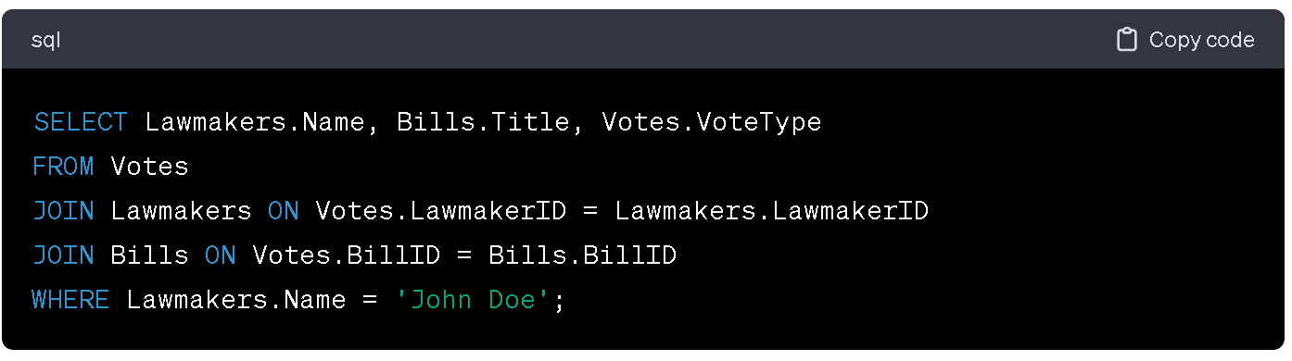

This query will provide a list of bills voted on by **'John Doe'**, including the type of vote they cast for each bill.

**Sample table.**   
Let’s include the **photo** of the lawmaker.

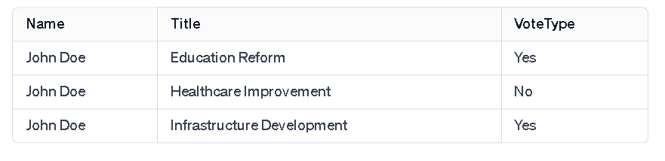

Database Schema for Government Agencies

# 1. Agencies Table

**AgencyID** (Primary Key, Integer): A unique identifier for each government agency.

**Name (**Varchar): The name of the agency.

**Type** (Varchar): Type of the agency (either 'Ministry' or 'Public Corporation').

# 2. Fiscal Years Table

**FiscalYearID** (Primary Key, Integer): A unique identifier for each fiscal year.

**Year** (Integer): The actual fiscal year (e.g., 2023).

# 3. Projects Table

**ProjectID** (Primary Key, Integer): A unique identifier for each project.

**AgencyID** (Foreign Key, Integer): Links to the AgencyID in the Agencies table.

**FiscalYearID** (Foreign Key, Integer): Links to the FiscalYearID in the Fiscal Years table.

**Name** (Varchar): The name of the project.

**Status** (Varchar): The current status of the project (Not Started, Started, Complete, Closed).

**BudgetAllocated** (Decimal): The budget allocated to the project.

**Expenditure** (Decimal): The current expenditure on the project.

Example of Usage

With this database structure, it will be easy to generate reports and insights. For instance, you can query to see all projects for a particular agency, including their budget, expenditure, and urrent status.

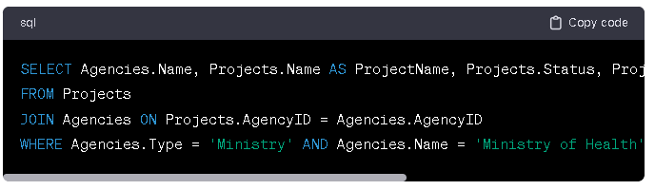

## **Sample agency budget**

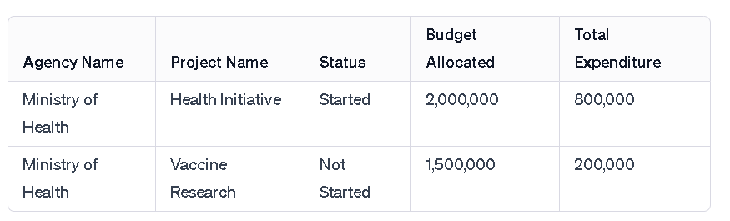

Database Schema for Judicial Courts

# 1. Courts Table

**CourtID** (Primary Key, Integer): A unique identifier for each judicial court.

**Name (**Varchar): The name of the court.

**Type** (Varchar): Type of the court (Supreme, District, etc).